📄 Technical Flow Document (Owner’s View)

1. Overview
This document explains the technical flow of the Owner’s view in the web portal. It covers the pop-up messages from the IT-Desk, owner’s dashboard page, daily/weekly/monthly reports, creation/credentials page, price-setting page and settings.

2. System Roles (For Scope Clarity)
- Owner View

3. User Flow Diagram (High-Level)
Here you list the main screens in order.
You can make a simple list like this:
- Login
- Dashboard
- Reports
- Chat Page
- Price/Discount Setting Page
- Users Page
- Settings
- Logout

4. Page-Level Technical Details (Core Part)
4.1 Page Name: Login
Login page would be as it is as in ‘Doc 1’

4.2 Page Name: Dashboard

1. Dashboard Overview Layer (Top Section)
Contains:
- Page Title: Sales Dashboard
- Short line: “Quick view of customer & product performance”
Failure Messages:
- Dashboard not loading
  - API down
  - Auth token missing
  - Wrong route /employee/dashboard
  - Backend permission issue

2. Top 10 Selling Customers (Table/Card View)
Data Shown:
- Customer Name
- Total Purchase Amount
- Total Orders
- Last Purchase Date
Backend API:
- GET /api/dashboard/top-customers
Failure Messages:
- No data available
- Customer data deleted
- API timeout
- Wrong aggregation logic

3. Brand Sales Bar Chart (Core Analytics Section)
Chart Type:
- Bar Chart
Filters:
- Year
- Month
- Day
Data Shown:
- X-axis: Sanitary Brands
- Y-axis: Total Sales Amount
Backend API:
- GET /api/dashboard/brand-sales?year=&month=&day=
Failure Messages:
- Chart not rendering
  - Chart library error
  - Empty dataset
- Wrong date filter
- Brand mapping missing
- Backend aggregation slow

4. Top 10 Popular Sanitary Items
Based On:
- Quantity sold (not price)
Data Shown:
- Product Name
- Brand
- Total Units Sold
- Category
Backend API:
- GET /api/dashboard/top-products
Failure Messages:
- Product deleted
- Sales data mismatch
- SKU not mapped
- No sales yet

5. Navigation Actions (Quick Access)
Buttons:
- Go to Catalogue
- Open Chat
- View Customer Details
Failure Messages:
- Button click does nothing
- Missing useNavigate()
- Wrong route
- Component not mounted

6. Tech Notes (Important for You)
- Dashboard loads before catalogue
- Read-only view (no edit here)
- All APIs should be aggregated queries
- Cache dashboard APIs (performance boost)

7. Repeat vs New Customers Insight
Purpose
Understand customer loyalty and retention strength.
Data Shown:
- New Customers (first purchase)
- Repeat Customers (2+ purchases)
- Percentage split
Chart Type:
- Pie Chart (primary)
- Stat Cards (quick summary)
Backend API:
- GET /api/dashboard/customer-retention
Insight Use:
- High repeat % → strong trust
- Low repeat % → need offers, follow-ups

8. Revenue Trend (Time-based Insight)
Purpose
Track business growth or decline over time.
Data Shown:
- Total Revenue by:
  - Day
  - Month
  - Year
Chart Type:
- Line Chart
Backend API:
- GET /api/dashboard/revenue-trend?range=
Failure Messages:
- Date filter mismatch
- Empty sales window

9. Stock Risk Insight
Purpose
Prevent out-of-stock sales loss.
Data Shown:
- Low stock products
- Zero stock products
Chart / Visual Type:
- Alert Cards
- Warning List Table
Backend API:
- GET /api/dashboard/low-stock
Insight Use:
- Early restocking
- Avoid missed orders

10. Category-wise Sales Share
Purpose
Identify top-performing categories.
Data Shown:
- Category Name
- Sales percentage contribution
Chart Type:
- Donut Chart
Backend API:
- GET /api/dashboard/category-sales
Insight Use:
- Focus marketing on high-share categories
- Optimize weak categories

11. High Value Customers (VIP Insight)
Purpose
Identify customers with highest lifetime value.
Data Shown:
- Customer Name
- Total Spend (LTV)
- Total Orders
Chart / Visual Type:
- Ranked Table
- Horizontal Bar Chart (optional)
Backend API:
- GET /api/dashboard/high-value-customers
Insight Use:
- Personalized offers
- Priority service

12. Price Sensitivity Insight (Advanced but Powerful)
Purpose
Analyze price vs demand relationship.
Data Shown:
- Product Price
- Units Sold (Demand)
Chart Type:
- Scatter Plot (Recommended ✅)
- Bubble Chart (Optional: bubble size = revenue)
Backend API:
- GET /api/dashboard/price-demand
Insight Use:
- Adjust pricing strategy
- Create bundles
- Identify premium vs weak products

13. Employee Activity Snapshot (Optional)
Purpose
Track internal catalogue activity.
Data Shown:
- Products added today
- Products updated today
- Catalogue changes count
Chart / Visual Type:
- Stat Cards
- Activity Log List
Backend API:
- GET /api/dashboard/employee-activity

Final Dashboard Flow (With Visuals)
1️⃣ Sales Summary → Stat Cards
2️⃣ Top Customers → Table / Bar Chart
3️⃣ Brand Sales → Bar Chart
4️⃣ Popular Products → Ranked List
5️⃣ Customer Retention → Pie Chart
6️⃣ Revenue Trend → Line Chart
7️⃣ Stock Alerts → Alert Cards
8️⃣ Category Share → Donut Chart
9️⃣ Price Sensitivity → Scatter Plot

4.3 Reports

Employee Reports Page
URL:
/employee/reports
Purpose
- Downloadable data
- Period-based analysis
- Share with owner / manager
- Audit + planning

1. Sales Reports (MOST IMPORTANT)
1.1 Sales Report
What it shows:
- Cash deposits
- Cash Payouts
- Net sales, Gross Sales, and Net Value
Search Bar:
- Type selection (PDF/Excel)
- Range Type (Monthly/yearly/weekly)
- Date selection
- Run Button
Format:
- Table
- PDF / Excel
Sales Report Contains:
Deposits
- Cash
- Cheques
- Online Payments
Payouts
- Cash Payouts
- Expenses
- Refunds
Sales Summary
- Gross Sales
- Discounts
- Returns
- Net Sales
- Taxes
- Net Total
Visuals
- User-wise Sales (Bar)
- Deposit-wise Sales (Bar)
- Day-wise Trend (Line)

1.2 Brand-wise Sales Report
What it shows
- Major Table
      - Brand name
      - Units sold (Pcs, ml, pkt)
      - Revenue
    - Secondary Table (Frequent selling products almost each day)
      - Product Name
      - Product average sale (Total sales)/(Total days) [Selecting weekly/monthly/yearly]
      - Units Sold
      - SKU
Chart
- Bar chart (showing total sales brand-wise)
Use
- Brand negotiations
- Stock planning

1.3 Product-wise Sales Report
What it shows
- Product name
- Brand-Name
    - SKU
    - Units sold
    - Revenue
Chart (If Excel)
- Horizontal grouped bar chart (It shows total sales of that product brand-wise with ‘revenue’ and ‘total units sold’)
Use
- Identify hero products
- Remove dead stock

2. Customer Reports
2.1 Customer Purchase History
What it shows
- Overall Purchase
      - Customer name
      - Discount grp
      - Customer Type
      - Last purchase date
      - Last purchase amount
      - Total Sales (weekly/monthly/yearly)
- Frequent Purchases [If (Total sales of a Product of that customer in that range) > (Total frequency of sales in that range)/2]
      - Product Name
      - Brand Name
      - Sub-category
      - Average sales amount
Use
- Complaints
- Relationship handling
Chart
- Vertical Bar Chart (Sales daily/Weekly/Monthly if weekly/monthly/yearly report)
2.2 Top Customers Report
What it shows
- Customers
(If sales are greater than the:
- 50k or equal to that on each purchase for retailers
- for builders
- for dealers
- for customers
- for projects)
      - Customer Name
      - Customer Category
      - Customer average Sales
      - Customer total Sales
      - Order Count
      - Coupons/Score
      - Last purchase date
Chart
- Ranked table
Use
- Loyalty programs

2.3 Inactive Customers Report
What it shows
- Retailers with no purchase in 30 days
- Consumers with no purchase in 6 months
- Builders with no purchase in last 3 months
- Dealers with no purchase in last 2 weeks
3. Inventory & Stock Reports
3.1 Current Stock Report
What it shows
- Product
- Category-type
- Current stock quantity
- Stock status (low/mid)
Use
- Daily operations

3.2 Stock Movement Report
What it shows
- Opening stock (Stock exactly at the beginning of the time range you are analysing)
- Sold quantity (Quantity sold during the period)
- Closing stock (Quantity left at the end of the period)
Use
- Audit
- Shrinkage check

3.3 Low Stock & Out-of-Stock Report
What it shows
- Products below threshold
Use
- Purchase planning

4. Pricing & Profit Reports (Advanced)
4.1 Price Sensitivity Report
What it shows
- Price vs demand
- Revenue impact
Chart
- Scatter plot
Use
- Price changes
- Bundles

4.2 Discount Impact Report
What it shows
- Discount applied
- Sales uplift
Use
- Check if offers work

5. Employee Activity Reports
5.1 Catalogue Change Report
What it shows
- Products added / updated
- Employee name
- Date
Use
- Control mistakes
- Accountability

6. Summary Reports (One-Click)
  - Daily Business Report
Auto-generated
- Sales
- Top product
- Low stock items
Format
- PDF

6.2 Monthly Business Report (Owner Favorito 🔥)
What it shows
- Revenue trend
- Best brands
- Best customers
- Stock risks
Use
- Strategic decisions

Report Page Layout (Simple)
Left Panel:
- Sales Reports
- Customer Reports
- Inventory Reports
- Pricing Reports
- Employee Reports
Right Panel:
- Filters
- Preview
- Download buttons

4.4 Chat Window
Purpose
To allow owner to:
- Monitor all employee–customer conversations
- Review order accept/reject actions
- Handle orders forwarded for approval
- Maintain audit and control over decisions made by employees
Chat’s flow:
- Window selection screen:
  - IT Employee chat
  - Personal Chat
- Personal Chat:
  - Upper-bar:
    - Backend messages
    - Chat
    - Notifications
The owner does not replace the employee chat, but oversees and intervenes when needed.

URL
/owner/messages

Contains (UI Components)
1. Conversation List (Left Panel)
Displays all active and escalated conversations.
Visible Fields:
- Customer Name / Company Name
- Customer Type (Retailer, Distributor, Contractor, Builder, etc.)
- Order Status
- Assigned Employee Name
- Last Message Preview
- Conversation Status:
  - Active
  - Forwarded for Approval
  - Order Accepted
  - Order Rejected
- Timestamp
- Unread Message Count
- Priority Tag (VIP / Bulk / Credit Issue)

2. Chat Window (Right Panel)
Header Section
- Customer Name
- Customer Type
- Customer Contact (optional)
- “View Full Order History”
- “View Customer Profile”

3. Chat History (Read-Only + Actionable)
Employee Chat:
Shows:
- Customer messages
- Employee replies
- System messages:
  - Order accepted
  - Order rejected (with reason)
  - Order forwarded to owner
- Timestamps
- Action labels (Accepted / Rejected / Forwarded)
⚠️ Owner cannot modify past employee messages.

Personal Chat:
- System messages:
Shows:
- System messages:
          - Forwarded Order Card (MOST IMPORTANT)
            - Appears when employee forwards an order.
            - Example Card:
            - Order Forwarded for Approval
Product: Premium Basin (x10)
Requested: 8 minutes ago,
Forwarded by: Rahul (Employee)
Employee Note: “Requires special discount approval”
            - Owner Actions:

              - ✅Approve Order
              - ❌ Reject Order
              - 💬 Send Note to Employee
  - Approve Order (Owner)
When owner clicks Approve → modal opens.
Fields:
- Confirm Product(s)
- Confirm Quantity
- Final Approved Price
- Delivery Date
- Optional Note (to employee & customer)
On Confirm:
- Order status updated to Approved
- Employee is notified
- Customer receives confirmation message (via WhatsApp)
- Redirect (optional): /owner/orders/{order_id}
  - Reject Order (Owner)
When owner clicks Reject → modal opens.
Required:
- Rejection Reason:
  - Pricing Not Approved
  - Credit Limit Issue
  - Stock Risk
  - Policy Restriction
  - Other (text input)
Optional:
- Note to Employee
- Short message to Customer
After Submission:
- Rejection reason logged
- Employee notified
- Customer receives rejection message
- Order marked Rejected by Owner
- Timestamps
- Action labels (Accepted / Rejected / Forwarded)

5. Notifications Panel (Owner-Level)
Owner can:
- View all notifications sent by employees
- Create high-level notifications
Supported Notifications:
- Payment due reminders
- Policy announcements
- Stock availability alerts
- Holiday / delivery delay notices
Messages appear in:
- Employee chat window
- Users chat window
- WhatsApp (if enabled)

6. Default / System Notifications (Owner Visibility)
Auto-generated system messages such as:
- Repeated payment due reminders after 10 days
- Low stock reminder at the end of the day around 7 pm
- High-value order alerts above 80000
- Bulk order detection above 60000
- Credit threshold breach
Owner sees:
- Trigger reason
- Affected customer(s)
- Employee involved

Backend APIs (Owner-Specific)
- Fetch Conversations
GET /api/owner/messages/conversations
- Fetch Chat History
GET /api/owner/messages/{conversation_id}
- Approve Forwarded Order
POST /api/order/owner/approve
- Reject Forwarded Order
POST /api/order/owner/reject
- Send Note to Employee
POST /api/messages/internal

Navigation Flow (Owner)
- Messages → Select Conversation
- Review Chat + Order Context
- If Forwarded:
  - Approve / Reject
- Monitor outcome
- Navigate to:
  - Orders
  - Customers
  - Reports

Failure Messages (Owner View)
Approval Errors
- “Order details incomplete.”
- “Pricing approval required.”
- “Unable to approve order. Try again.”
Forwarded Order Errors
- “Order no longer available.”
- “Employee not assigned.”
- “Approval window expired.”
Permission Errors
- “You do not have approval rights.”
- “This order does not require owner approval.”

4.5 Owner Control Panel – Master Data & Discount Management

Purpose
To give the owner full authority over:
- Discount groups and pricing rules
- Product master data (categories, sub-categories, brands, products)
This page ensures:
- Controlled pricing
- Margin protection
- Clean and reliable master data
- No dependency on employees for critical business decisions

URL
/owner/master-control

Access Control
Accessible only to:
- Owner
- Super Admin
Employees:
- ❌ Cannot add or edit products
- ❌ Cannot create or modify discount groups
- ❌ Cannot change pricing rules

Page Layout (UI Structure)

1️⃣ Filter & Search Section (Top Panel)
Filters Available (with edit access):
- Product ID (read-only search)
- Product Name (with Add New Product button)
- Category (Dropdown)
- Sub-category (Dropdown – depends on category)
- Brand (Dropdown)
Search section:
We can search anything via that search space like google
Actions:
- Apply Filters
- Reset Filters
Filters affect all discount groups.

2️⃣ Discount Group Selector (Control Layer)
Positioned above the table.
◀ [ Retail Customers ▼ ] ▶
Components:
- ⬅ Left Arrow → Previous discount group
- ➡ Right Arrow → Next discount group
- Dropdown → Jump directly to any discount group
Behaviour:
- Only one discount group active at a time
- Table refreshes when group changes
- Arrows auto-disable on first / last group
- Dropdown always enabled
Helper Info:
Editing prices for: Retail Customers
Group 2 of 8

3️⃣ Pricing Table (Clean & Stable)
Purpose:
Edit pricing rules for the selected discount group only.
Table Columns (Fixed & Minimal):
Column | Description
Product ID | Reference (non-editable)
Product Name | Primary identifier
Category | High-level grouping
Brand | Product brand
Base Price | Read-only
Discount % | Editable
Final Price | Auto-calculated
Status | Active / Inactive
Actions | Save / Edit
✔ No horizontal scrolling
✔ Same layout for all discount groups

4️⃣ Table Behavior
- Discount % edits update final price instantly
- Save applies only to the selected discount group
- Products not applicable to a group show:
- Not Applicable
- Inactive products are visually muted

5️⃣ Add / Edit Discount Group (Modal)
Triggered From:
- Discount group management section (owner only)
Fields:
- Group Name (read-only)
- Category (read-only)
- Sub-category (read-only)
- Brand (read-only)
- Default Discount %
- Status (Active / Inactive)
Buttons:
- Save
- Cancel

Validations & Business Rules
- Duplicate discount group names are not allowed
- Discount % cannot exceed maximum allowed
- Final price cannot violate minimum margin
- Invalid inputs block save with clear message

Backend APIs Used
Fetch Discount Groups
GET /api/discount-groups
Fetch Products for Selected Group
GET /api/products?discount_group_id={id}
Create Discount Group
POST /api/discount-groups/create
Update Discount Group
PUT /api/discount-groups/{id}

Failure Messages & Errors
Pricing Errors
- “Discount exceeds allowed limit.”
- “Final price violates minimum margin.”
Permission Errors
- “Owner access required.”
- “You do not have permission to modify pricing.”
System Errors
- “Unable to load pricing data.”
- “Failed to save changes. Try again.”
- “Server temporarily unavailable.”

Summary
This page acts as the central pricing engine of the system:
- One discount group at a time
- Clean UI
- Strong validation
- Owner-level control
It prevents:
- Pricing chaos
- Margin loss
- Unauthorized changes

4.6 Users Page (User & Customer Management)
Purpose
To allow the owner to:
- View all users (customers, distributors, builders, employee)
- Create new users
- Edit or delete users
- Drill down into employee → their customers

URL
/owner/users

Access Control
- Owner: Full access (create, edit, delete)
- Admin: Limited (edit, view)
- Employees: ❌ No access

Page Layout Overview
- Top Filter / Search Section
- User Summary Cards
- Users Table
- User Actions (Edit / Delete / View)
- Employee → Customer Drill-down

1️⃣ Search Section
Search Filters (Below Tabs)
Filters:
- Username (text input)
- User Group (dropdown)
  - Final Customer
  - Retailer
  - Distributor
  - Builder
  - Employee
- User ID (optional)
Search Bar:
Here, the user can search anything like in Google search bar.
Buttons:
- Search
- Reset Filters

  - Add New User (Owner only)

2️⃣ User Group Selector (Control Layer)
Positioned above the table.
◀ [ Retailers ▼ ] ▶
Components:
- ⬅ Left Arrow → Previous user group
- ➡ Right Arrow → Next user group
- Dropdown → Jump directly to any user group
The above part would be visible if the selected users are ‘all users’.

3️⃣User Summary Cards (Quick Stats)
Displayed above the table:
- Total Users
- Total Final Consumers
- Total Retailers
- Total Distributors
- Total Builders
Helps owner understand:
- Customer mix
- Business reach

4️⃣ Users Table
Table Columns
Column Name | Description
User ID | Unique system ID
Name | Full name
Username | Login username
Email | Email address
Phone | Contact number
Shop Name | Business name (if applicable)
User Group | Customer / Distributor / etc
Residential Address | Address
Last Login | Date & time
Status | Active / Inactive
Actions | Edit / Delete / View

Actions Column
- ✏️ Edit User
- 🗑 Delete User
- 👁 View Details
Delete:
- Soft delete (status = inactive)

4️⃣ Add / Edit User Flow
Add New User (Modal / Page)
Fields:
- Full Name
- Username (unique)
- Email
- Phone Number
- User Group (dropdown)
- Shop Name (optional)
- Residential Address
- Password (auto-generated or manual)
- Status
Buttons:
- Save
- Cancel

Validations
- Username must be unique
- Email format check
- User group mandatory

5️⃣ Employee Click → Customer View
When Owner Clicks on an Employee
Redirects to:
/owner/users/{employee_id}/customers

Employee Customer Summary Section
Cards:
- Total Customers
- Final Consumers Count
- Retail Consumers Count
- Distributor Consumers Count

Employee’s Customers Table
Columns:
- Consumer ID
- Consumer Name
- Phone Number
- Consumer Type
- Rewards Points
- Total Purchases
- Last Purchase Date
Actions:
- View Consumer
- Purchase History

6️⃣ Customer Search (Inside Employee View)
Filters:
- Consumer Name
- Phone Number
- Consumer Type
- Consumer ID
Search Bar

7️⃣ Rewards & Loyalty (Optional but Powerful)
Displayed per customer:
- Reward Points
- Tier (Silver / Gold / Platinum)
- Redeem History (optional)

8️⃣ Backend APIs (Example)
GET /api/users
POST /api/users/create
PUT /api/users/{id}
DELETE /api/users/{id}

GET /api/employees/{id}/customers

9️⃣ Error & System Messages
- “Username already exists.”
- “User deleted successfully.”
- “Access denied.”
- “Unable to load users.”

4.7 Settings
Purpose
Provide employees with control over personal preferences and system configurations, including notification settings, order alerts, password changes, UI appearance, and language preferences.
This page helps employees personalize how the system behaves for them.

URL
/employee/settings

Contains
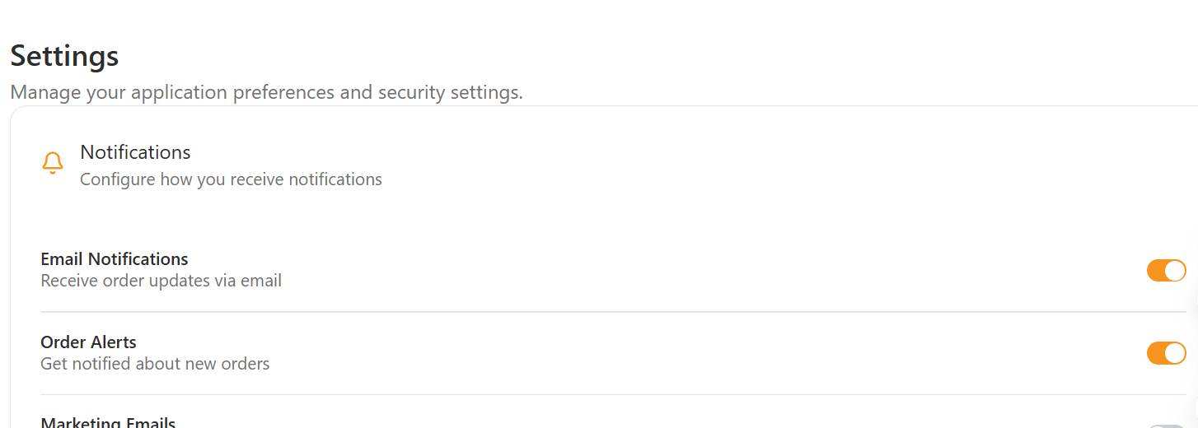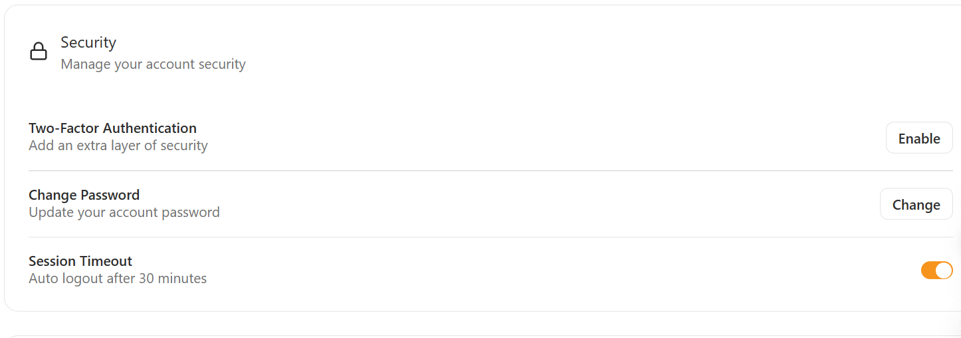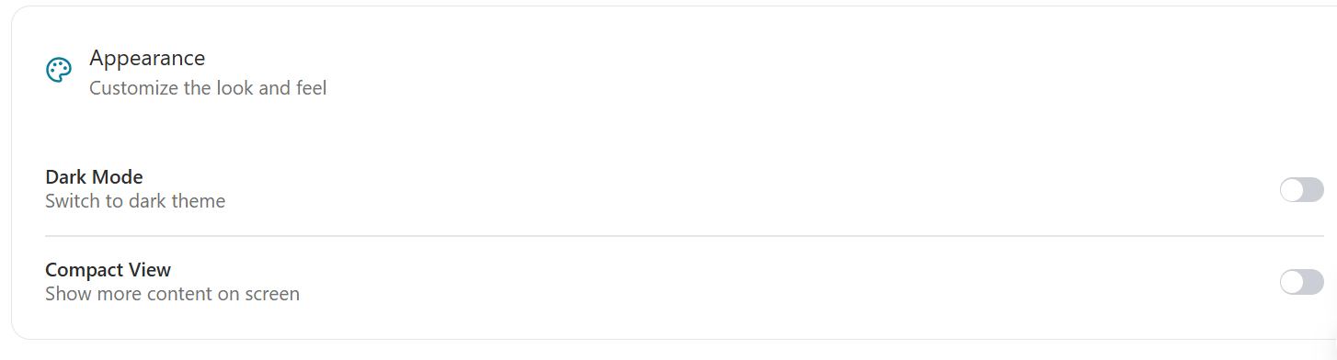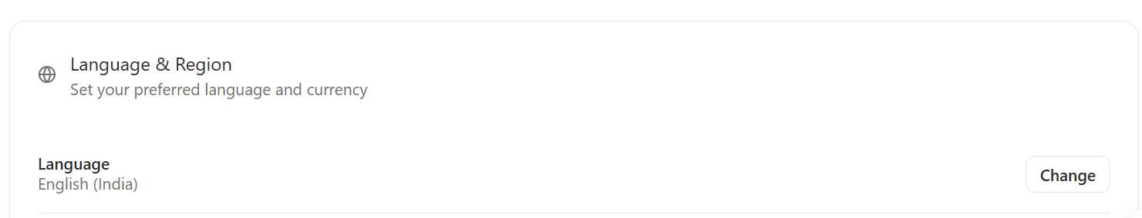
1. Notification Settings
- Toggle New Order Alerts
- Toggle Low Stock Alerts
- Toggle Customer Messages Alerts
- Toggle System Notifications
2. Order Alerts Configuration
- Set alert sound ON/OFF
- Set vibration mode (for mobile)
- Priority level setting:
  - High priority = Always show popup
  - Medium priority = Show in notifications panel
  - Low priority = Silent
3. Account Settings
- Change Password
  - Old password
  - New password
  - Confirm new password
- Logout button
4. Display Settings
- Dark Mode Toggle
(Light / Dark / Auto System Mode)
5. Language
- Language selection dropdown
  - English
  - Hindi
  - Punjabi
- Number format
6. Other Optional Controls
- Clear cache / Reset saved filters
- Manage connected devices
- Allow/disallow email alerts
Actions
- Save Settings
- Reset to Default
- Test Notification Sound

Backend APIs
GET /api/employee/settings
Used to fetch the existing settings for the logged-in employee.

PATCH / PUT /api/employee/settings/update
Used to update:
- Notification preferences
- Display mode
- Language settings
- Alert configurations

POST /api/employee/change-password
Used to update password securely.

Failure Messages and Errors (Settings Page)
This section lists all possible errors that employees might face.
1. Loading Errors
- “Unable to load settings. Please try again.”
- “Network issue. Failed to fetch settings.”
Causes:
- Backend unavailable
- Network disconnection
- Invalid authentication token
2. Save / Update Errors
- “Failed to save settings.”
- “Unable to update notification preferences.”
- “You do not have permission to change this setting.”
- “An unexpected error occurred while updating your settings.”
Causes:
- API error
- Incorrect payload format
- Employee privilege issues
- Server timeout
3. Change Password Errors
- “Old password is incorrect.”
- “New password must be at least 8 characters.”
- “Passwords do not match.”
- “Failed to change password. Try again later.”
- “This password was used recently. Choose a different one.”
Causes:
- Wrong old password
- Weak new password
- Server validation failure
4. Notification Settings Errors
- “Failed to update notification preferences.”
- “Notification sound file missing.”
- “Push notifications are disabled by the browser.”
Causes:
- Browser blocking notifications
- Incorrect alert configuration
- Missing audio file
5. Dark Mode / Display Errors
- “Failed to apply dark mode.”
- “Display settings could not be saved.”
Causes:
- Browser storage issue
- UI rendering conflict
6. Language Selection Errors
- “Selected language not available.”
- “Translation files failed to load.”
Causes:
- Missing translation JSON
- Server not sending language assets
7. Reset to Default Errors
- “Unable to reset settings.”
- “Server failed to apply default configuration.”
8. Authentication Errors
- “Session expired. Please log in again.”
- “Unauthorized access to settings.”

6. Error Handling Rules
- Session timeout → redirect to login
- Invalid ID → show “Record not found”
- Missing fields → show small alert

7. Security Notes
- JWT token required for all API calls
- Role-based access
- No employee should see other sites unless allowed

8. Future Scope
Add features later such as:
- Chatbot
- Notifications
- Multi-branch linking

